**Food Living Outside Play Technology Workshop**

**9 Channel "pure analog" graphic equalizer**

by **Marc_Escobaem** on January 8, 2015

**Table of Contents**

9 Channel "pure analog" graphic equalizer . . . . . . . . . . . . . . . . . . . . . . . . . . . . . . . . . . . . . . . . . . . . . . . . . . . . . . . . . . . . . . . . . . . . . . . . . . . . . . . . . . . . . . . . . . . 1 Intro: 9 Channel "pure analog" graphic equalizer . . . . . . . . . . . . . . . . . . . . . . . . . . . . . . . . . . . . . . . . . . . . . . . . . . . . . . . . . . . . . . . . . . . . . . . . . . . . . . . . . . . 2 Step 1: Circuit ideas . . . . . . . . . . . . . . . . . . . . . . . . . . . . . . . . . . . . . . . . . . . . . . . . . . . . . . . . . . . . . . . . . . . . . . . . . . . . . . . . . . . . . . . . . . . . . . . . . . . . . . . . 3 Step 2: The whole circuit . . . . . . . . . . . . . . . . . . . . . . . . . . . . . . . . . . . . . . . . . . . . . . . . . . . . . . . . . . . . . . . . . . . . . . . . . . . . . . . . . . . . . . . . . . . . . . . . . . . . . 4 Step 3: Routing . . . . . . . . . . . . . . . . . . . . . . . . . . . . . . . . . . . . . . . . . . . . . . . . . . . . . . . . . . . . . . . . . . . . . . . . . . . . . . . . . . . . . . . . . . . . . . . . . . . . . . . . . . . . 4 Step 4: Finished equalizer . . . . . . . . . . . . . . . . . . . . . . . . . . . . . . . . . . . . . . . . . . . . . . . . . . . . . . . . . . . . . . . . . . . . . . . . . . . . . . . . . . . . . . . . . . . . . . . . . . . . 5

File Downloads . . . . . . . . . . . . . . . . . . . . . . . . . . . . . . . . . . . . . . . . . . . . . . . . . . . . . . . . . . . . . . . . . . . . . . . . . . . . . . . . . . . . . . . . . . . . . . . . . . . . . . . . . . . 6 Related Instructables . . . . . . . . . . . . . . . . . . . . . . . . . . . . . . . . . . . . . . . . . . . . . . . . . . . . . . . . . . . . . . . . . . . . . . . . . . . . . . . . . . . . . . . . . . . . . . . . . . . . . . . . 7 Advertisements . . . . . . . . . . . . . . . . . . . . . . . . . . . . . . . . . . . . . . . . . . . . . . . . . . . . . . . . . . . . . . . . . . . . . . . . . . . . . . . . . . . . . . . . . . . . . . . . . . . . . . . . . . . . . . . 7 Comments . . . . . . . . . . . . . . . . . . . . . . . . . . . . . . . . . . . . . . . . . . . . . . . . . . . . . . . . . . . . . . . . . . . . . . . . . . . . . . . . . . . . . . . . . . . . . . . . . . . . . . . . . . . . . . . . 7

http://www.instructables.com/id/9-Channel-pure-analog-graphic-equalizer/

**Intro: 9 Channel "pure analog" graphic equalizer**

Video!

This is a short Instructable, where i will provide you the techniques to create a pure analog equalizer to visualize your music!

This equalizer is based on several active filters, amplifiers and one row of a simple voltage meter per channel. This one row consists out of 7 LED to visualize the amplitude of the current signal/frequency.

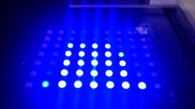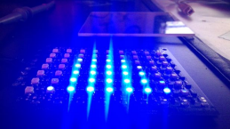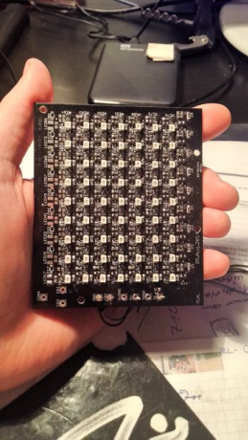

http://www.instructables.com/id/9-Channel-pure-analog-graphic-equalizer/

**Step 1: Circuit ideas**

The function of an graphic equalizer is to distinguish incoming signals by frequency and show their amplitude by LEDs or a display.

The basics are really simple. As one may know, there are several ways to get a proper visualisation of the musik spectrum between its 10 to 20kHz. The one which is most in common is the one via a digitization and a fourier transform. There are also several ICs available for creating an equalizing effect and show it on LEDs. But for learning purposes and because i want a pure analog one i created this following one for myself.

The equalizer consists out of an audio input. This input signal is filtered by a active notch filter - active, because i need a high filter order - and the lasting signal is amplified. This signal gets rectified and represents now the size of the frequency (chosen for the notch) in the actual audio signal. This is as simple as it can get.

The filter configuration i used is a single ended multiple feedback bandpass filter, consisting out of two opamps and having a gain of 10dB. To design those filters you can use you head and the mathematics behind this kind of circuitry. If you dont have the time for this you can use toole like TIs Filter Pro software.

The frequency bands i used where: 50Hz, 120Hz, 250Hz, 500Hz, 1kHz, 2kHz, 4kHz, 8kHz and 16kHz. Therefore i need 9 filter circuits. The output of such a filter circuit is an specific amount of amplitude of the filtered signal. This signal is will be rectified by a diode and an additional capacitor smoothes the signal to a DC signal. Its amplitude stays in relation to the amplitude of the frequency band. A simulation of three filters in shown in one image above!

I implemented a simple voltage meter with LEDs to show the signal strength. The technique behind this is really simple. The voltage falls over each diode with something around 700mV - this is the step size. if the voltage is high enough to overcome one diode, the transistor becomes conductive and the LED is ON.

The all over circuit consist of 9 filter circuits, 9 voltage meters with 7 LEDs for each channel and a preamplifier for the incoming signal to adjust the signal strength afterwards.

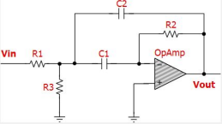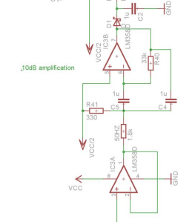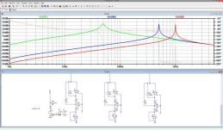

http://www.instructables.com/id/9-Channel-pure-analog-graphic-equalizer/

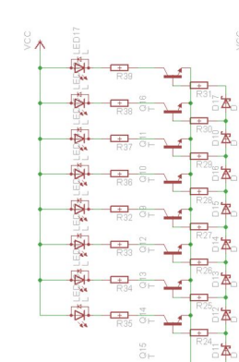

**Step 2: The whole circuit**

The hardest part of the work is to calculate the filter circuits, even if you use the tool from TI. The picture shows its dimension. The toughest problem, which one cannot see by designing the circuit, is the problem of potential oscillations of the filter circuits. A wrong configuration of the OpAmps and the Resistors and capacitors can lead the filter circuit to oscillations and this is, as you can think, really bad - because it simply does not work anymore!

Nonetheless i found a configuration which worked for me - the eagle files are attached in the end of this instructable!

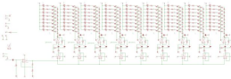

**Step 3: Routing**

The build up became a little bit tricky, since i had some limitations of my board to 10*10cm^2. But with a little bit of routing experience, it is possible. The repetition of the circuits makes it even easier.

The filter circuits and amplification parts are placed on the buttom side. The voltagemeters are placed on the front.

As you may have recognized, the whole circuit dont have a build in supply/voltage regulator. It works with external 10V and external 5V reference voltage. This also keeps the circuit small.

!! Important remark: !!

Make sure, your 5V reference supply can act as a sink, since its not in source configuration. That means it has to sink up to a few hundred mA (around 200). Some supplys dont work with that. Maybe build the reference yourself with the 10V and a proper IC.

http://www.instructables.com/id/9-Channel-pure-analog-graphic-equalizer/

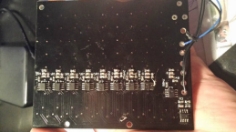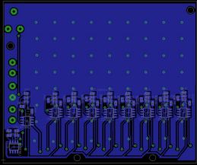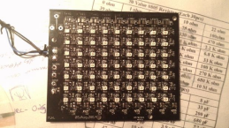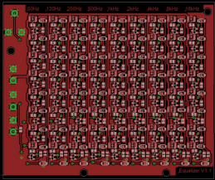

**Step 4: Finished equalizer**

Equalizer with signalgenerator (sweep from 10Hz to 20kHz, 10Hz increment)

Equalizer with music

There may be some wrong bridges in the layout or i did some changes in the meantime, so please send me a message before you make a pcb, so i can look on it again =)

Hope you liked my instructable, although it is a really short one!

Feel free to leave a comment, if you have something to say about this.

http://www.instructables.com/id/9-Channel-pure-analog-graphic-equalizer/

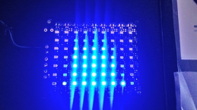

**File Downloads**

**V1.0.brd** (320 KB)

[NOTE: When saving, if you see .tmp as the file ext, rename it to 'V1.0.brd']

http://www.instructables.com/id/9-Channel-pure-analog-graphic-equalizer/

**V1.0.sch** (509 KB)

[NOTE: When saving, if you see .tmp as the file ext, rename it to 'V1.0.sch']

**Related Instructables**



**Linux**

**Recording**

**Arduino based Bi-color LED Matrix Audio**

**Automatic Headphone Equalizer** by

**Girino - Fast Arduino**

**Beat**

**Detecting LEDs**

**ATtiny85**

**Spectrum Analyzer with**

**Studio Software Components** by reteo

**Spectrum**

**Visualizer** by jollifactory

**Advertisements**

**Comments**

JackZhuPaulQuigley

**Oscilloscope** by

Caffeinomane

**in Resin** by johnmedz

**fix_FFT** by shinteo

**1 comments Add Comment**

**Jan_Henrik** says: Jan 12, 2015. 10:49 AM **REPLY** I love it!

http://www.instructables.com/id/9-Channel-pure-analog-graphic-equalizer/